**Come and try Bridge**

**It’s a great game if you want to have fun; Socialise with friendly, local people and Stimulate your brain.**

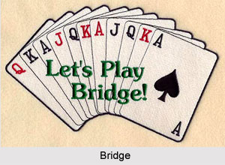

**We invite you to learn to play *BRIDGE with us at the Wynnum Manly Bridge Club.***

***Lessons are FREE!***

**Our experienced trainer will run beginner’s classes on Thursday afternoons, beginning 9th February 2023 at the Wynnum Library . Classes run for 6 weeks. After you’ve completed the classes, you’ll be invited to join our supervised games where an experienced player will be by your side to assist you.**

When you’re ready, you can join our normal playing sessions on:

* Wednesday mornings and Friday afternoons
* at the Wynnum Memorial Hall, 219 Bay Terrace.
* The cost for members is just $5 per game.

To get started or to find more information, please call

**0493 546 906**

Or email us at [wynnummanlybridgeclubinc@hotmail.com](mailto:wynnummanlybridgeclubinc@hotmail.com).

(Minimum numbers required for classes to be held)

We look forward to welcoming you!