

**Rotary**

Club of Capalaba

**Heritage** **DAY**

**Saturday 13th April**

**9am to 1 pm**

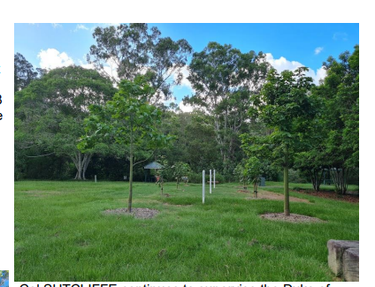The Rocks (photo right), like a lot of South East Queensland Parks has green, green grass but suffering because the mowers can’t get onto the grounds. The 8 trees around the Peace Poles are now established .

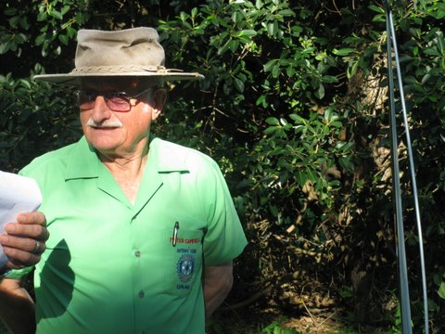Now is the time we need the late Rotarian Peter CAMPBELL to give us some advice. Peter was the visionary for the Rotary Club of Capalaba establishing The Rocks Project over 20 years ago.

**Save the Date, 13TH April ,** it is time to celebrate this great project with a **Free Event** in West John Fredericks Park, on the banks of Tingalpa Creek.

**For Updates and More Information**

**Contact: Email:** [**Capalabarotary@gmail.com**](mailto:Capalabarotary@gmail.com)

**Qr Code**